Artur Barbosa

January 27th, 2016

CMPT 308_200

Professor Rivas

**Lab 1**

**Data vs. Information**

Data and information to your average person may sound like the same thing. However, without information, data means nothing. In simpler terms, data is the building block of information when that data is organized and put into useful context, it is then considered information. To relate this to database management, I will compare it to an Oracle database, however the concepts may be applied to many other databases. Within the database there are things like metadata, which structure how the tables will be utilized. For example, something that could be stored as data could be a data type for a particular field, or just someone’s name. In that database, when the tables are created and populated with data that wouldn’t be very useful alone, (i.e. name, address, bank account number, and account savings) it becomes information. The newly structured data can be read by humans and can be considered information. Now that the data has been given context, it becomes valuable. It is no longer standalone data that could almost be considered meaningless. It is now an organized table of information that is way more valuable than raw data. In short, data is meaningless without information because standalone data typically doesn’t have a context and cannot be easily interpreted by humans.

**Data Models**

Data models are very important when it comes to database management. Data models provide an organized way to view elements of the database and how the relate to each other. Most data models use symbols and text to help show the viewer the relationships among the database. One of the first data model used in databases was the hierarchical structure. In hierarchical database models, the data is organized in a tree-like structure. The hierarchical model was created by IBM in the 1960’s and was short-lived due to the many improvements on storing data. It was difficult to build extensive databases that are popular in big companies toady because each child record has only one parent. Also, they were inefficient in recalling data because the whole tree needs to be traversed to retrieve data. Another data model that expands upon the hierarchical structure is the network model. This model allows many-to-many relationships, which allow multiple parents. The network model was an improvement when we compare it to the hierarchical model however, it was nowhere as efficient and powerful as the relational model. Edgar F. Codd created the relational model in 1969. This data model provided something that the others did not. It provided a declarative method for specifying data and queries. Through SQL, users can specify the data they want to retrieve from the database, even if they are in different tables.

Considering this, I think that the XML data model serves as a baseline where more complex models can be built off. It is a useful method of storing data, however I believe that the relational model is superior.

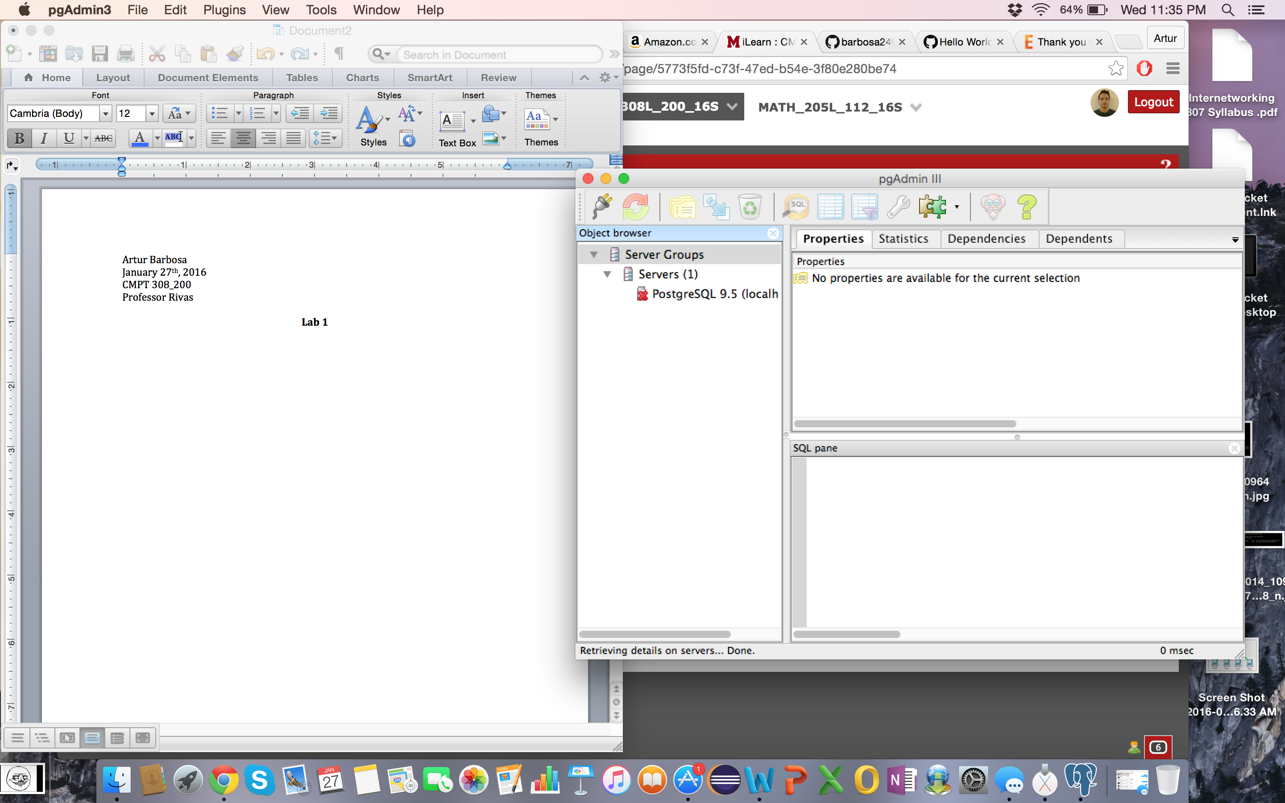 to